A Word template for Volcanica
First Author^{1,2}, Second Author*², and Third Author²
¹ First affiliation
² Second affiliation
* email@address.io [corresponding author]
ORCiD (FA): 0000.0000.0000.0000
ORCiD (SA): 0000.0000.0000.0000
ORCiD (TA): 0000.0000.0000.0000
Keywords: Please; Provide; Up; To; Six; Keywords

Abstract

Abstract text goes here—no more than 150 words. Please use only the styles included in this template (see Home > Styles Pane): MS title, Authors, Affiliations, Abstract, Normal (for text), and Headings (levels 1–3). Figures can be embedded in this document, or uploaded as separate files. They can be included in the manuscript file at the appropriate point, but please place any tables at the end of the text. Please use the Caption style to include figure and table captions. If ORCID numbers are available for the authors, please include them above. Please also include an email address for the corresponding author, and six keywords. To maximise the findability of your article online, consider using keywords that are not already in the title. UK or US English is acceptable, as long as you are consistent throughout. For any questions or issues regarding this template, email editor@jvolcanica.org. Happy writing!

Second-language abstract

A second language abstract may go here. No more than 150 words. Lorem ipsum dolor sit amet, consectetur adipiscing elit. Integer nec odio. Praesent libero. Sed cursus ante dapibus diam. Sed nisi. Nulla quis sem at nibh elementum imperdiet. Duis sagittis ipsum. Praesent mauris. Fusce nec tellus sed augue semper porta. Mauris massa. Vestibulum lacinia arcu eget nulla. Class aptent taciti sociosqu ad litora torquent per conubia nostra, per inceptos himenaeos. Curabitur sodales ligula in libero. Sed dignissim lacinia nunc. Curabitur tortor. Pellentesque nibh. Aenean quam. In scelerisque sem at dolor. Maecenas mattis. Sed convallis tristique sem. Proin ut ligula vel nunc egestas porttitor. Morbi lectus risus, iaculis vel, suscipit quis, luctu.

Section (as Heading 1)
Define any equations in the Equation environment:
$f\left(x\right)=a_{0}+\sum_{n=1}^{∞}{\left(a_{n}\cos{\frac{nπx}{L}}+b_{n}\sin{\frac{nπx}{L}}\right)}$ (1)
where $a_{0}$ corresponds to … Suspendisse a elit ut leo pharetra cursus sed quis diam. Nullam dapibus, ante vitae congue egestas, sem ex semper orci, vel sodales sapien nibh sed lectus. Etiam vehicula lectus quis orci ultricies dapibus. In sit amet lorem egestas, pretium sem sed, tempus lorem.

Citations may be in-line: Einstein and Rosen (1935), or in parentheses (Einstein and Rosen 1935), as appropriate.

Subsection (as Heading 2)
Figure sizes should not exceed 85 × 200 mm (for single column figures) or 175 × 200 (for two column figures).

Subsection (as Heading 2)
Ut rutrum, sapien et vulputate molestie, augue velit consectetur lectus, bibendum porta justo odio lobortis ligula. In in urna nec arcu iaculis accumsan nec et quam. Integer ut orci mollis, varius justo vitae, pellentesque leo. Vestibulum eu finibus nisl. Cras ac arcu urna. Duis ut pellentesque urna.

Subsubsection (as Heading 3)
In placerat dictum urna ut interdum. Etiam vel nibh vulputate, scelerisque purus in, congue eros. Pellentesque at nisi at nunc sagittis cursus. Mauris euismod tellus at mi tempor, sit amet finibus ante tincidunt. Aenean id ornare neque. Cras ut sapien quis erat pretium ultricies. Integer vulputate ante nec elementum tristique. Ut. Lorem ipsum dolor sit amet, consectetur adipiscing elit. Mauris dictum, nibh ut condimentum pharetra, quam ligula varius est, sed vehicula massa erat ut metus. In eget metus lorem. Fusce vitae ante dictum, elementum sem non, lacinia dui. Integer tellus tortor, convallis et aliquam non, dictum vel mauris. Quisque maximus mollis dui, a mollis mauris vehicula in. Duis dui ligula, suscipit ac lectus vitae, fringilla euismod diam. Suspendisse a elit ut leo pharetra cursus sed quis diam. Nullam dapibus, ante vitae congue egestas, sem ex semper orci, vel sodales sapien nibh sed lectus. Etiam vehicula lectus quis orci ultricies dapibus. In sit amet lorem egestas, pretium sem sed, tempus lorem. Quisque cursus massa sed urna congue, ac convallis neque consectetur. Proin faucibus neque non metus mollis, suscipit pretium nisl blandit. In hac habitasse platea dictumst. Nam laoreet augue eu odio eleifend, non posuere quam pulvinar. Integer sit amet leo vitae nisl facilisis tristique.

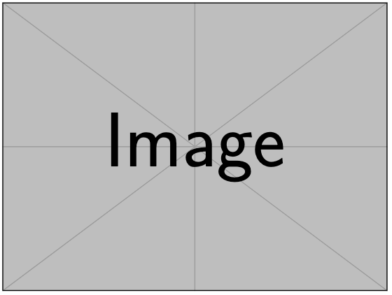
Figure 1: Figures can be inserted in-line or at the end of the manuscript, along with their captions. This is a single-column figure (85 mm).

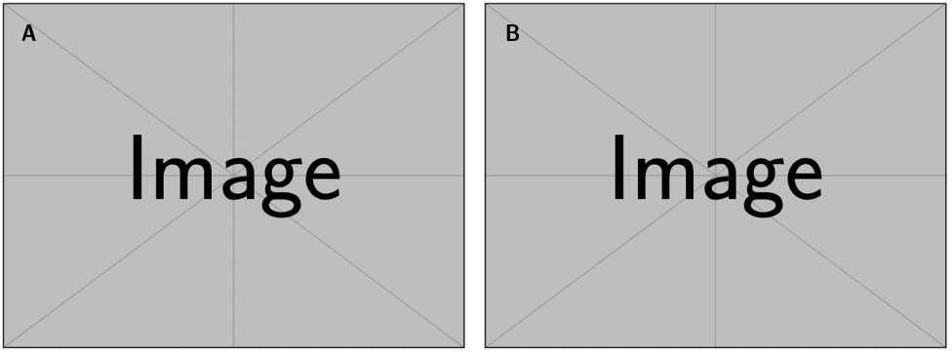
Figure 2: This is a two-column figure (175 mm). Note that separate panels are labelled with an upper-case letter, in a size 12 sans-serif font. [A] Something about the first panel. [B] Something about the second panel.

Introduction
Generally, an article follows an Introduction > Methods > Results > Discussion > Conclusions structure, but this is a guideline rather than a rule!

Geological background

Methods and materials

Results

Discussion

Conclusions

Author contributions
Tell us who did what.

Acknowledgements
Thank all relevant parties and acknowledge funding sources, if any.

Data availability
Authors should direct readers to an open access repository where the relevant data can be accessed, and provide a statement regarding data availability. Authors are strongly encouraged to make data freely available wherever possible: we recommend free repositories such as Zenodo and FigShare in order to facilitate transparent open access. We recommend versioning, archiving, and sharing code via GitHub/Zenodo; see: https://docs.github.com/en/repositories/archiving-a-github-repository/referencing-and-citing-content.

References
References should be included at the end of the manuscript, in APA style: http://www.bibme.org/citation-guide/apa/. Where possible, DOI numbers should be provided.

Author, A. (Publication Year). Article title. Periodical Title, Volume(Issue), pp.-pp. DOI: 10.XXXX/XXXX

Einstein, A. and Rosen, N. (1935). The particle problem in the general theory of relativity. Physica Review, 48(1):73. doi: 10.1103/PhysRev.48.73

